MODELE DE SUBIECTE PENTRU TESTUL DE COMPETENȚE LINGVISTICE PENTRU ADMITEREA ÎN CLASA A V-A CU PROGRAM INTENSIV DE STUDIU AL UNEI LIMBI DE CIRCULAȚIE INTERNAȚIONALĂ
PROBA SCRISĂ
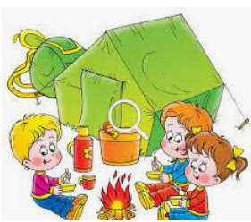
Look at the picture showing children on a summer camp.

Write a composition using the following words in any order you like:

TENT BUCKET AROUND RUCKSACK (=BACKPACK) IN FRONT OF

Write about:
- what the children in the picture are doing
- what the children look like and what they are wearing
- what else you can see in the picture
- what you do when you are on your summer holiday

PROBA ORALĂ PARTEA I : TEACHER – STUDENT
Read the text and answer the questions:

In Mexico the traditional clothes help people stay cool. Men wear big hats and large cotton clothes. Women and little girls wear long colourful dresses and flowers in their hair. In Japan the traditional costume is the kimono. Men's kimonos are usually black, but women's kimonos have beautiful colours with drawings of flowers, leaves and birds. In India men prefer long elegant shirts and special hats called turbans. Women decorate their long colourful dresses with beads and mirrors. They also wear rings, bracelets, earrings and sometimes nose rings.

- What are the three countries mentioned in the text?
- In which country do men wear a traditional costume in only one colour?
- In which country do women wear many jewels?

PROBA ORALĂ PARTEA a II-a : STUDENT – STUDENT

Talk to your partner about BOBBY’S BIKE:
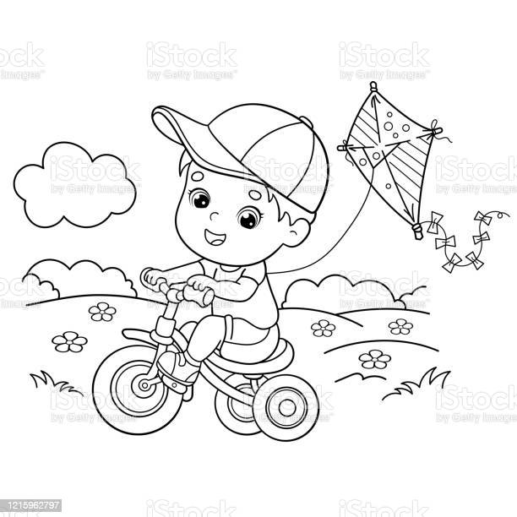

Student A | Student B
1.Ask Student B if Bobby has a bike. | 1.Answer Student A’s question about Bobby’s bike.
2.Ask Student B where Bobby rides his bike. | 2.Answer Student A’s question  about where Bobby rides his bike.
3.Ask Student B about the number of wheels. | 3.Answer Student A’s question  about the number of wheels.

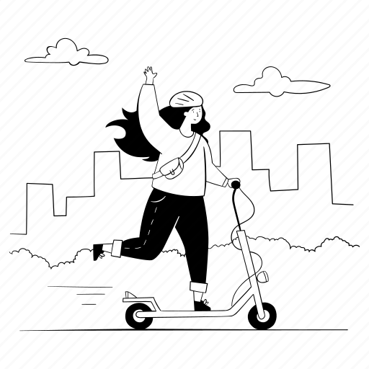
Talk to your partner about TINA’S SCOOTER:

Student B | Student A
1.Ask Student A if Tina likes riding her scooter. | 1.Answer Student B’s question about Tina’s scooter.
2.Ask Student A where Tina usually rides her scooter. | 2. Answer Student B’s question  about where Tina usually rides her scooter.
3.Ask Student A about the size of the wheels. | 3.Answer Student B’s question  about the size of the wheels.

